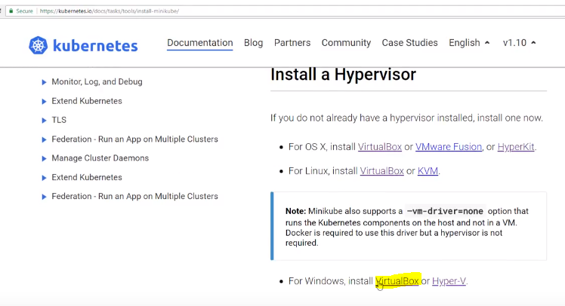

Download kubectl and 

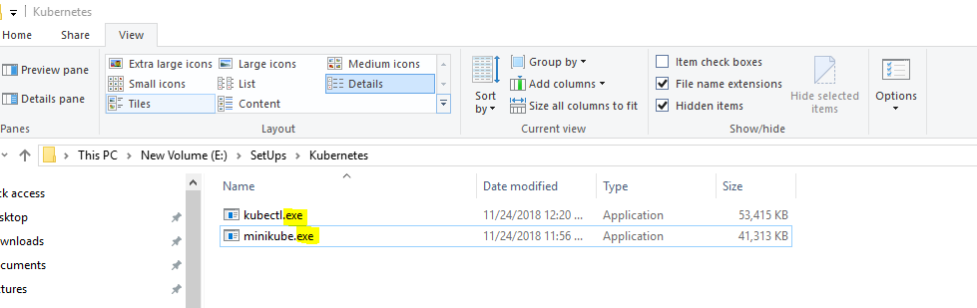

Set this path in Environmental Variable’s **Path**.

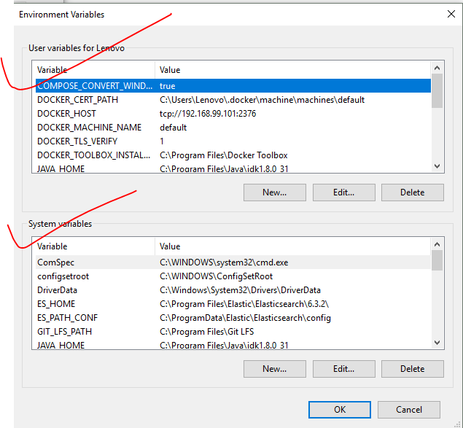

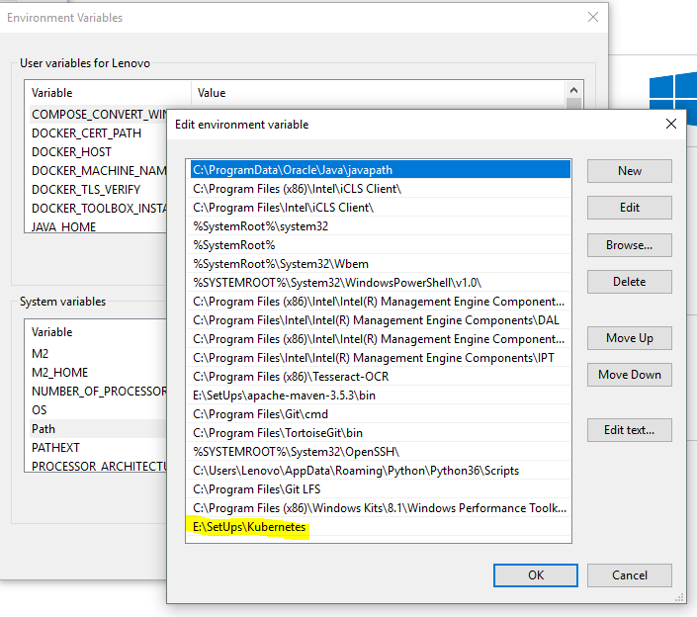

**Installing Cygwin**

You can download **Cygwin** [**https://www.cygwin.com/**](https://www.cygwin.com/)

A large collection of GNU and Open Source tools which provide functionality similar to a [Linux distribution](https://en.wikipedia.org/wiki/Linux_distribution) on Windows.

While you install cygwin, you will encounter a step where you will need to download the Linux Libraries, type and choose – keep, ftp, openssl, vim, etc. These are the basic packages that we will/may be required as basic building blocks for Cygwin ! To understand everything about Cygwin, refer this <https://www.youtube.com/watch?v=hh-V6el8Oxk>

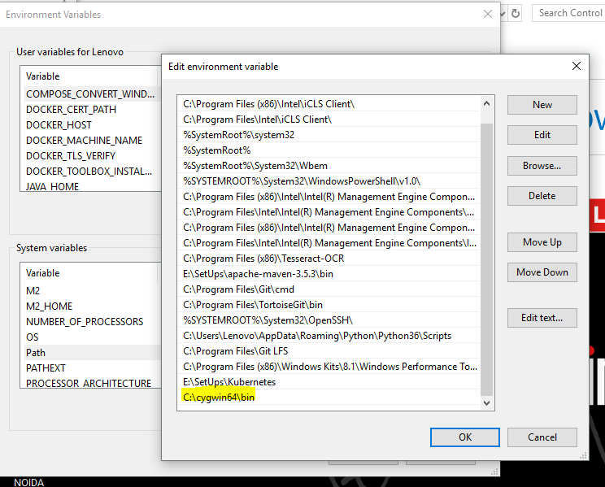

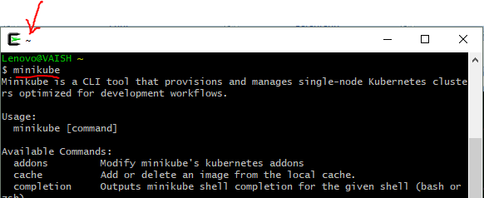

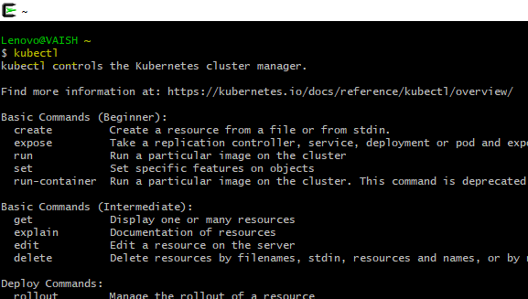

**To start the Kubernetes on your local machine -**

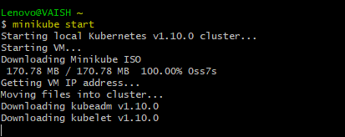

When you issue the above command (minikube is a Kubernetes one node cluster), you can notice the initiation of VM here :

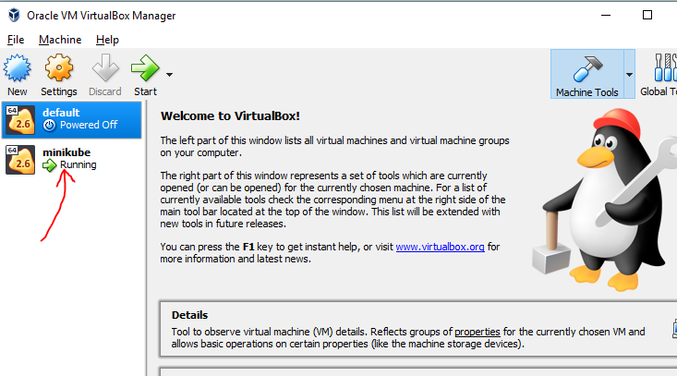

***P.S. The first picture shows that we need a Hypervisor. For Windows, its mentioned VirtualBox or Hyper-V( WIN-10 PRO). I don’t have WIN-10 PRO, but because I had VirtualBox installed on my laptop, so the initiation started happening over here!***

Minikube (which is one node Kubernetes cluster) is started now, if you want to view the system on **browser**, you can issue a below command :

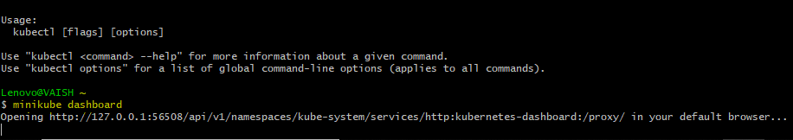

After the issuing of the above command, the Kubernetes system initiated on browser

